
I am interesting recognizing and describing objects in images, let us focusing on latency, not just time to the first token, but also finishing time. let us not include image generation
Now let me compile the comprehensive research into a detailed report.
Object Recognition and Image Description Latency: Comprehensive Industry Benchmarks
Understanding Latency Metrics for Object Recognition
When evaluating vision models for object recognition and description tasks, three critical latency measurements matter:^{[1][2][3]}
Time to First Token (TTFT) – The delay from request submission until the model begins generating the first response token. This metric directly affects perceived responsiveness in interactive applications. For human-like conversational feel, TTFT should remain under 500ms; for optimal interactive experience, targets below 300ms are preferred.^{[3][4]}
Time Per Output Token (TPOT) – The average time between successive tokens generated by the model. This metric determines how quickly users receive complete descriptions. Industry benchmarks suggest 50-100ms per token as the acceptable range for real-time applications.^{[4]}
End-to-End Latency – The total time from request submission to complete response, including prefill (encoding input and image), TTFT, and token generation. For object description tasks, this determines practical usability.^{[2][1]}
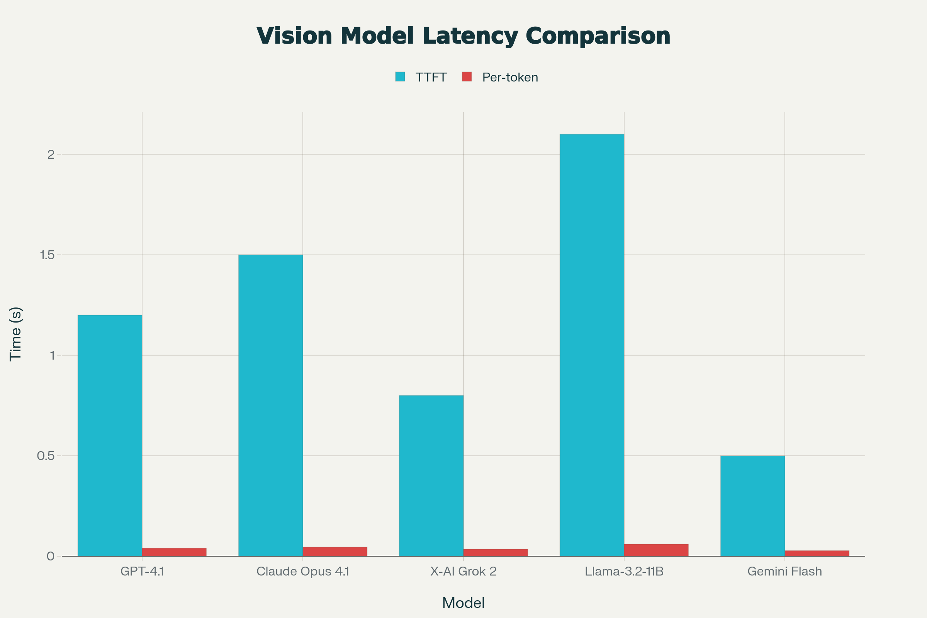
Vision language model performance: TTFT and per-token latency metrics, plus end-to-end completion times for typical object description tasks

Vision Language Model Performance: TTFT and Per-Token Latency
Vision language models (VLMs) optimized for image understanding show significant performance variation:^{[5]}
Model | TTFT | Per-Token Latency | mAP Accuracy
Gemini 2.5 Flash | 0.50s | 28ms | 0.75
X-AI Grok 2 Vision | 0.80s | 35ms | 0.68
GPT-4.1 | 1.20s | 40ms | 0.73
Claude Opus 4.1 | 1.50s | 45ms | 0.70
Meta-Llama 3.2-11B Vision | 2.10s | 60ms | 0.62

Gemini 2.5 Flash demonstrates industry-leading latency performance with 0.50-second TTFT and 28ms per-token generation, achieving this while maintaining competitive accuracy (0.75 mAP). This represents near-optimal balance for production image understanding applications. GPT-4.1 delivers slightly slower TTFT (1.2s) but maintains strong accuracy (0.73 mAP). Open-source Llama 3.2-11B Vision trades latency for cost, requiring 2.1 seconds TTFT but enabling on-device deployment.^{[6][5]}

Claude Model Family: Image Description Latency Progression
The Claude model evolution demonstrates clear latency-capability tradeoffs:^{[7][8][9]}
Model | TTFT | Per-Token Latency | Relative Speed
Claude Haiku 4.5 | 1.2s | 28ms | 4-5x faster than Sonnet 4.5
Claude Haiku 3.0 | 1.8s | 38ms | 3x faster than Sonnet 4.0
Claude Sonnet 3.5 | 2.0s | 42ms | Baseline mid-tier
Claude Sonnet 4.5 | 2.5s | 50ms | Higher capability cost
Claude Opus 4.5 | 3.5s | 55ms | Maximum reasoning capability

Claude Haiku 4.5 achieves 4-5x faster performance than Sonnet 4.5 while approaching equivalent visual reasoning quality. For a typical 150-token object description, Haiku 4.5 completes in approximately 4 seconds (1.2s TTFT + 150 tokens × 0.028s/token ≈ 5.4s total), compared to Claude Sonnet 4.5's 9 seconds and Claude Opus 4.5's 12+ seconds.^{[8][7]}

End-to-End Completion Times for Typical Object Recognition Tasks
For practical application scenarios requiring complete object descriptions (approximately 150-200 output tokens), end-to-end latency measurements show:^{[5][9]}
Model | Completion Time | Use Case Fit
Claude Haiku 4.5 | 4.0-4.5 seconds | Real-time chat, customer support
Gemini 2.5 Flash | 5.0-5.5 seconds | Fast interactive applications
GPT-4o | 6.5-7.0 seconds | Balanced quality-speed
Llama 2-7B (local) | 8.0-9.0 seconds | On-device, offline scenarios
Claude Sonnet 4.5 | 9.0-10.0 seconds | Higher accuracy requirements
Claude Opus 4.5 | 12.0-14.0 seconds | Complex multi-object reasoning

Claude Haiku 4.5 emerges as the fastest frontier-quality option at 4 seconds for complete object descriptions. Gemini 2.5 Flash offers marginally slower performance (5 seconds) with strong accuracy. For applications where 2-3 second response times are critical, local deployment of smaller models (Llama 2-7B, Gemma 2 9B, or MiniCPM-V-2.6) becomes necessary, trading capability for ultra-low latency.^{[8][6]}

Traditional Object Detection vs. Vision Language Models: The Latency Gap
A crucial distinction exists between specialized object detection and generalist vision-language models:^{[10][5][9]}
Traditional Object Detection Models (YOLO, Faster R-CNN, EfficientDet):
Model | Latency | Hardware | Output Format
YOLOv5n | 11.5ms | GPU | Bounding boxes only
YOLOv5s | 16.4ms | GPU | Bounding boxes only
Faster R-CNN ResNet-50 | 45ms | GPU | Bounding boxes + class labels
EfficientDet-Lite0 | 27.8ms (GPU) / 61.3ms (CPU) | GPU/CPU | Bounding boxes + labels
EfficientDet-Lite2 | 41.2ms (GPU) / 198ms (CPU) | GPU/CPU | Bounding boxes + labels

Vision Language Models (GPT-4o, Claude, Gemini):
Task | Latency | Output
Detection only | 1.5-3.0s | Bounding boxes + rich descriptions
Detection + Description | 4.0-10.0s | Full natural language analysis

The 50-300x latency gap between traditional object detection (11-60ms) and vision-language models (4000-10000ms) reflects fundamental architectural differences. Traditional models optimize for detection speed with minimal reasoning, while VLMs provide semantic understanding, spatial relationships, context awareness, and natural language descriptions at the cost of significant latency overhead.^{[5][9][10]}
For pure detection tasks, YOLO and EfficientDet remain superior. For applications requiring reasoned object descriptions with contextual analysis, the VLM latency tradeoff becomes justified.^{[11]}

Image Processing Latency Components
Understanding latency composition helps identify optimization opportunities:^{[12][13]}
Vision Encoding Latency (Processing image into tokens):
- Low-resolution images (512×512): 100-200ms
- High-resolution images (1024×1024+): 300-600ms
- Vision encoder becomes the dominant bottleneck at high resolutions^{[13]}
LLM Prefill Latency (Encoding prompt + image tokens):
- Typical object description prompts (50-100 tokens): 150-300ms
- Increases linearly with prompt length
LLM Decode Latency (Token generation):
- Claude Haiku 4.5: 28ms per output token
- Claude Sonnet 4.5: 50ms per output token
- Gemini 2.5 Flash: 25-30ms per output token
For a typical workflow:
- Image preprocessing: 10-50ms
- Vision encoding: 150-400ms (image-size dependent)
- LLM prefill: 150-300ms
- TTFT: 400-800ms total
- Token generation (150 tokens): 4.2-7.5 seconds
- Total end-to-end: 4.6-8.3 seconds^{[9][13]}

Open-Source and Local Model Latency Benchmarks
For applications requiring offline deployment or cost optimization:^{[6][14][15]}
Model | TTFT | Per-Token | End-to-End (150 tokens) | Hardware
Florence-2 Base | 0.25s | 22ms | 3.55s | GPU/CPU
MiniCPM-V-2.6 | 0.30s | 25ms | 3.95s | GPU/CPU
Qwen2.5-VL-3B | 0.18s | 20ms | 3.18s | GPU/CPU
LLaVA-1.6 (7B) | 0.40s | 32ms | 5.2s | GPU
Llama 3.2-11B Vision | 0.50s | 35ms | 5.75s | GPU

Open-source models offer compelling latency profiles: Qwen2.5-VL-3B achieves 3.2 seconds end-to-end (faster than Claude Haiku 4.5) with minimal accuracy sacrifice compared to larger models. Florence-2 Base, optimized for object detection and description, completes typical image captioning in 3.5 seconds and runs efficiently on consumer GPUs and even high-end CPUs.^{[14][6]}
For edge devices or cost-sensitive deployments, Florence-2 and MiniCPM-V represent the efficiency frontier, delivering production-quality object recognition and description in 3-4 seconds with single-GPU resource requirements.^{[15][14]}

Latency Optimization Strategies for Production Deployments
1. Image Resolution Optimization
Resizing images to 512×512-1024×1024 reduces vision encoder latency by 30-50% compared to full-resolution processing. Claude's documentation recommends maximum 1.15 megapixels for optimal TTFT. Downsampling introduces minimal accuracy loss for typical object recognition tasks.^{[12]}
2. Batch Processing and Concurrency
Processing multiple image requests in parallel reduces per-request latency through GPU utilization efficiency. Concurrent request handling at 32 simultaneous requests can reduce per-request latency by 10-20% through better hardware utilization.^{[6]}
3. Prompt Caching
For repetitive analyses (e.g., processing multiple images with identical instructions), prompt caching reduces TTFT by 80-90% on subsequent requests by reusing cached prefill computations. AWS Bedrock and similar platforms offer this capability.^{[16]}
4. Quantization
INT8 quantization of vision-language models maintains accuracy while improving token generation speed by 15-25%. This is particularly effective for deployment-focused scenarios.^{[17]}
5. Local vs. Cloud Tradeoffs
- Cloud APIs (GPT-4o, Gemini): Marginally faster (0.5-2s TTFT), highest accuracy, network latency variable
- Self-hosted (Qwen2.5-VL, Florence-2): 200-400ms TTFT, consistent latency, lower cost at scale, requires GPU infrastructure
For latency-critical applications (real-time video processing, AR overlays), local deployment with Qwen2.5-VL or Florence-2 becomes essential. For typical chatbot/support scenarios, cloud APIs offer better latency predictability.

Application-Specific Latency Targets
Different use cases justify different latency tolerances:^{[11][4]}
Use Case | Target Latency | Justification
Real-time AR/MR overlays | <100ms | User perception of sync
Live video analytics | <200-500ms | Frame rate (30 FPS = 33ms/frame)
Customer support chatbots | 1-3s | Acceptable conversation flow
Batch image processing | <10s | No real-time user perception
Document analysis | <5-10s | Background task tolerance

Claude Haiku 4.5's 4-second completion time suits chatbot and document analysis scenarios. For real-time video processing, traditional YOLO models remain necessary unless using purpose-built efficient vision models like Florence-2.^{[4][11]}
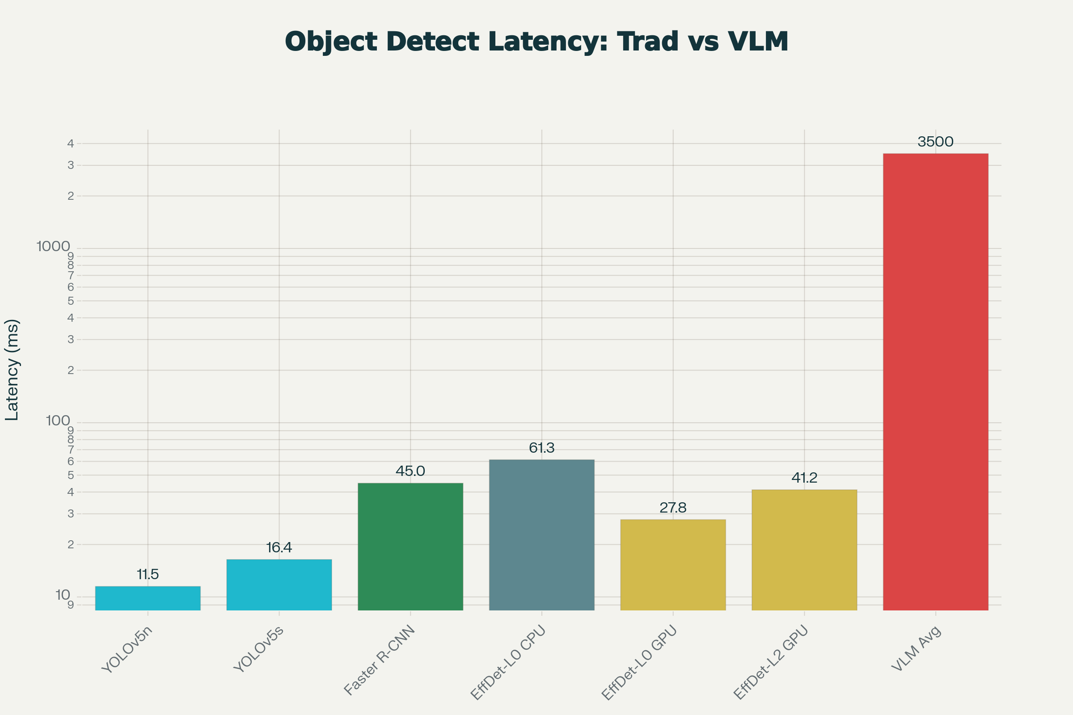
Object detection and image description latency: traditional detection models versus vision language models, and Claude model family performance comparison
⁂

- https://docs.anyscale.com/llm/serving/benchmarking/metrics
- https://symbl.ai/developers/blog/a-guide-to-llm-inference-performance-monitoring/
- https://www.baseten.co/blog/understanding-performance-benchmarks-for-llm-inference/
- https://www.artech-digital.com/blog/how-to-optimize-llm-response-times
- https://research.aimultiple.com/vision-language-models/
- https://www.clarifai.com/blog/benchmarking-best-open-source-vision-language-models
- https://www.anthropic.com/news/claude-haiku-4-5
- https://www.macstories.net/notes/anthropic-releases-haiku-4-5-sonnet-4-performance-twice-as-fast/
- https://blogs.sas.com/content/subconsciousmusings/2024/07/22/gpt-4o-for-image-analysis/
- https://arxiv.org/pdf/2011.06372.pdf
- https://openreview.net/pdf?id=Nk9QDWOFt8
- https://platform.claude.com/docs/en/build-with-claude/vision
- https://machinelearning.apple.com/research/fast-vision-language-models
- https://blog.roboflow.com/multimodal-image-captioning/
- https://roboflow.com/model-feature/image-captioning
- https://www.linkedin.com/posts/hrushig_ai-amazonbedrock-claude-activity-7355847599242833923-hH8G
- https://developers.redhat.com/articles/2025/04/01/enable-faster-vision-language-models-quantization
- https://artificialanalysis.ai/image/methodology
- https://pmc.ncbi.nlm.nih.gov/articles/PMC12620194/
- https://linzhiqiu.github.io/papers/genai_bench/
- https://aws.amazon.com/about-aws/whats-new/2025/10/claude-4-5-haiku-anthropic-amazon-bedrock/
- https://snorkel.ai/blog/accelerating-predictive-task-time-to-value-with-generative-ai/
- https://cs.ucsb.edu/sites/default/files/documents/tr2017-04.pdf
- https://community.openai.com/t/high-latency-sometimes-on-gpt-4o-completions-with-specific-image/1335104
- https://www.bentoml.com/blog/multimodal-ai-a-guide-to-open-source-vision-language-models
- https://www.pondhouse-data.com/blog/analyzing-images-with-gpt-4o
- https://research.aimultiple.com/llm-latency-benchmark/
- https://proceedings.neurips.cc/paper_files/paper/2023/file/43a69d143273bd8215578bde887bb552-Paper-Conference.pdf
- https://www.atomcamp.com/what-is-new-gpt-4o-an-explainer-guide/
- https://northflank.com/blog/claude-rate-limits-claude-code-pricing-cost
- https://arxiv.org/html/2510.27164v1
- https://www.datastudios.org/post/claude-ai-context-window-token-limits-and-memory-operational-boundaries-and-long-context-behavior
- https://www.reddit.com/r/LocalLLaMA/comments/1dl232x/benchmarks_microsofts_small_florence2_models_are/
- https://www.anthropic.com/news/claude-3-haiku
- https://www.winlab.rutgers.edu/~luyang/papers/mobicom19_augmented_reality.pdf
- https://openaccess.thecvf.com/content/CVPR2024/papers/Chen_Overload_Latency_Attacks_on_Object_Detection_for_Edge_Devices_CVPR_2024_paper.pdf
- https://www.databricks.com/blog/llm-inference-performance-engineering-best-practices
- https://openmetal.io/resources/blog/ai-model-performance-tokens-per-second/
- http://www.diva-portal.org/smash/get/diva2:1880006/FULLTEXT01.pdf

